Analysing Film texts – Warhorse (2011)

The attack of the English light infrantry is a moment of great anticipation & surprise. With refrence to camera, explain how Spielberg used the camera to elicit emotion in the audience.
Spielberg used the camera to elicit emotion in the audience with a shot showing the captain yelling and then everyone follows. Then he uses a moving shot showing all of the men on the horses yelling and chraging towards the Germans with their swords up. When they get up on their horses in the field you get a rush of adrenaline because you know what they a re about to do.

`

The plow scene with Albert & Joey was a highly emotive moment in the film Warhorse. With reference to acting & sound, explain how Spielberg managed to capture the moment.
Spielberg managed to capture the moment with acting by having Albert try his absolute hardest in the rain and tried to get Joey to do the same. Albert kept going up to Joey to try and get him to move and then pats him to get him warmed up. Spielberg also uses sound to capture the moment by using an uplifting soundtrack when Joey finally starts to plough through the ground. This gets your emotions up because heaps of people thought he would fail, and he proved them all wrong. The rain also helps capture the moment because it is just another struggle that the 2 have to go through. And makes it more special when they succeed.

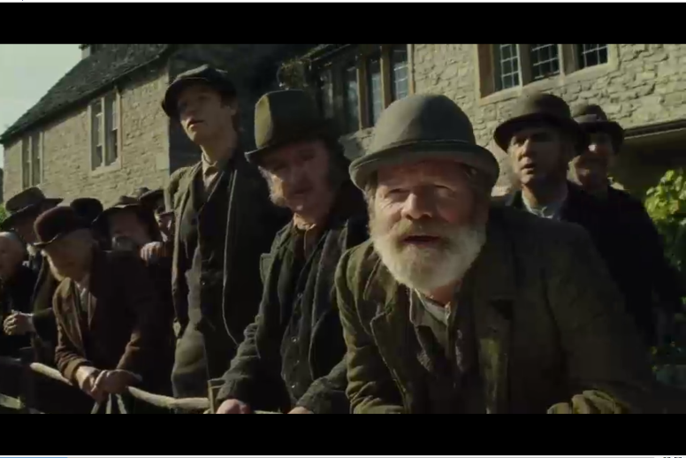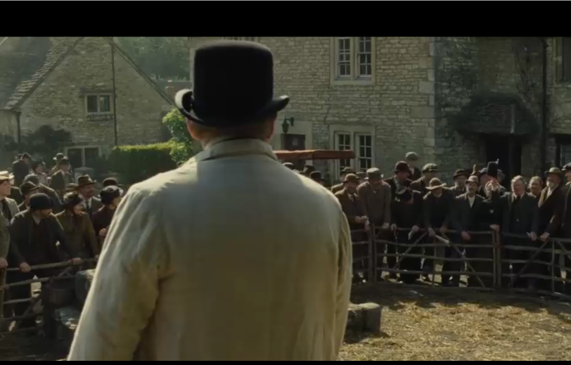

The Saleyard scene involves a tense battle between the landlord & Ted Narricot. Explain how Spielberg created this atmosphere with reference to a technical code & convention of film narratives.

Spielberg uses mise-En-scene to develop the characters in the saleyard scene by putting the rich people on one side and the poorer people on the other side. This shows that the landlord is richer than Ted Narricot, but ted still out bids him which means that Ted has spent way more money than he has and for a horse that may not be able to plough. The people around the horses are sort of lined up in a social scale from highly wealthy and respected people to the less wealthy and less respected people.

